Neo,
I wrote this up for you to share with your team. This is the result of lots of personal research on my part.
Ken

The popularity of first-person virtual reality games is largely due to their realistic real-time color graphics. The player actually moves around in the game world, as if the game were looking through the players eyes. Simulating a three-dimensional room or landscape can be a very time-consuming and computationally complex exercise. Doing the simulation in real-time is even harder. The programmers behind these types of games know how to squeeze the most performance out of the processor. Attention must be paid to execution time at every step. In addition, it is also necessary to have a good understanding of algebra and trigonometry (as well as physics) to write the necessary graphic routines.
In this section we will examine the theory behind a simple first-person game called Virtual Maze. The player 'walks' through the maze by pressing the arrow keys or by moving the mouse. The goal is to reach an 'Exit' door.
The Virtual Maze game changes the computers video mode and uses a 320 by 200 pixel resolution, with 256 colors. Figure 1 shows a sample screen shot.

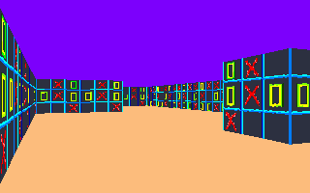

Figure 1: Raycast scene with distance-based perspective

The technique used to draw the game screen is called ray-casting. The ray casting must be done as fast as possible so that the screen updates in real-time. Let us see how ray casting works.

Ray Casting

The basic method behind ray casting follows this sequence of steps:

1. Pick a direction for the ray.
2. Find the distance to the first horizontal intersection of the ray with an object.
3. Find the distance to the first vertical intersection of the ray with an object.
4. Pick the intersection with the smallest distance.
5. Use the distance to calculate the height of a vertical strip to draw on the screen.
6. Draw the texture-mapped strip.

The objects in Virtual Maze are walls. So, steps 2 and 3 are actually finding the distance to the closest wall in front of the player. The height of the wall is based on its distance from the player. The larger the distance, the smaller the height. Figure 2 shows a sample ray being cast.

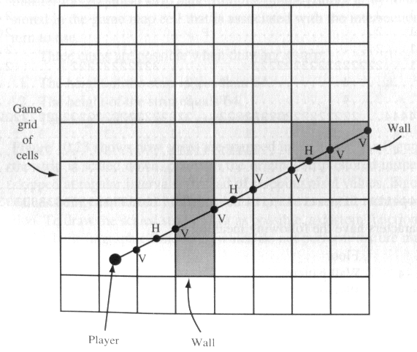

Figure 2: Casting a ray

The ray begins at the players position and extends outward until it eventually hits the edge of the game world, which is composed of a rectangular grid of cells, where each cell represents a 64 by 64 section of the overall game world. The 8 by 8 game grid in Figure 2 actually represents a 512 by 512 world. Each cell contains one of three things: the player, a floor section, or a wall section.
Finding the intersection of a ray involves checking horizontal intersections (H in Figure 2) and vertical intersections (V). Notice that there are only three horizontal intersections in Figure 2, and seven vertical ones. Some of these intersections hit cells that contain wall sections. The second vertical intersection (the first to hit a wall) is closer to the player than the third horizontal intersection (also the first to hit a wall). A texture-mapped strip from the wall associated with the closer vertical intersection is drawn.
To generate a screen, 320 rays are cast. The players direction is used to cast out rays beginning at 30 degrees minus the players direction, and going to 30 degrees plus the players direction. This sweeps a 60 degree arc over the game field. Each ray cast results in one column of pixels drawn on the screen (the strip from steps 5 and 6). So, casting 320 rays results in an entire screen of the game world being drawn.

Representing the Game World

As previously mentioned, the game world is represented by a rectangular grid of cells, each of which contains information about a specific 64 by 64 section of the virtual game world. The game world rendered by Virtual Maze is stored in a ASCII file called GAMEMAP.DAT, which looks similar to this:

1111111111111111111111111111111111114444444444444444444444444444
1...................................4..........................4
1...................................4..........................4
1...................................4..........................4
1...222222...2222222222222222...22222222222222222222222....44444
1........2.......4..........2...2..............................1
1........2.......4..........2...2..........................11111
1....1...2...222222222222...........2222222222222222222....13E33
1....1...2............................................2....1...3
144441...2....................P.......................244441...3
4....1...2............................................2....1...3
4....1...2222222222222222...........22222222222.......2....1...3
4............4..............2...2..........................1...3
4............4..............2...2..........................1...3
4...44444...22222222222222222...2222222222222222222222222221...3
4......4.................1........1.......3.......3........3...3
4......4.................1111111111.......3.......3........3...3
4......4..............................3.......3.......3........3
4......4..............................3.......3.......3........3
4444444411111111111111111111111111111133333333333333333333333333

where the characters have the following meaning:

. Floor
1-4 Wall patterns
P Player
E Exit

Virtual Maze reads in the GAMEMAP.DAT file at the beginning of the game. The cell containing P is the initial player position. The player is only allowed to move into cells that are floor cells, or into the Exit cell (which ends the game).
The game grid is stored in ASCII so that you may create your own virtual maze with a simple text editor, such as the EDIT utility supplied with DOS.

The Walls

The patterns for the walls are stored in various PCX image files. Each wall (there are ten) is represented by a block of 4096 bytes, organized into a 2-dimensional array that contains data for a 64 by 64 pixel pattern. One column of the array specifies one column of pixels (a strip) on the screen. Each pixel can be one of the 256 standard VGA colors.
The five wall patterns are loaded into a global 3-dimensional array at the beginning of the game. An additional pattern is the Exit wall.
Drawing a strip of a wall is done after the nearest intersection is found and the distance to it has been calculated. The distance is used to scale the height of the strip so that its height changes in proportion to distance. The maximum height is limited to 200 pixels, since the resolution of the game screen is 320 by 200.
When the height of the strip is known, a technique called texture mapping is used to transfer the graphical strip data from the global pattern array to the screen. The character stored in the game map cell that is associated with the intersection specifies the wall pattern to use.
There are three cases to consider when drawing a strip:

1. The height of the strip is less than 64.
2. The height of the strip equals 64.
3. The height of the strip is greater than 64.

Figure 3 shows how strips are mapped in each case.

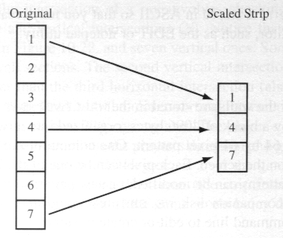

Figure 3(a): Strip is scaled down (original pixels are skipped over during rendering)

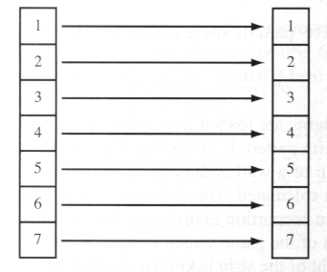

Figure 3(b): No scaling

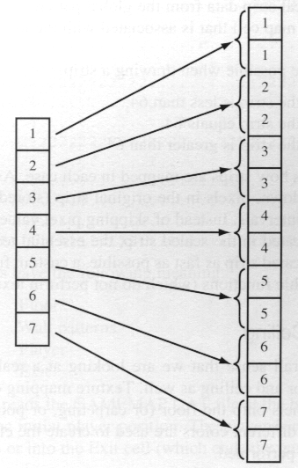

Figure 3(c): Strip is scaled up (zoomed). Original pixels are duplicated.

As Figure 3(a) shows, when the strip is scaled down, pixels in the original strip (stored in the global walls array) are skipped at regular intervals. Instead of skipping pixels values, Figure 3(c) shows pixel values being duplicated in the scaled strip, the essential technique behind a zoom operation. To draw the scaled strip as fast as possible, a custom function is used, rather than one of the built-in graphic functions.

The Floor and Ceiling

To add to the overall sense that we are looking at a real environment, it is necessary to simulate the floor and ceiling as well. Texture mapping can be used to map lights onto the ceiling and panels onto the floor (or carpeting, or pools of radioactive material). Or, simply, two different colors can be used to create the effect of a floor and ceiling. Figure 4 illustrates the components of an entire column of pixels in the game screen.

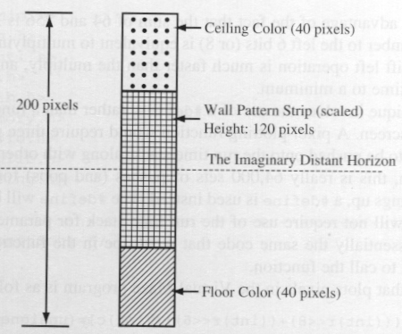

Figure 4: One column of pixels in a game screen

In this example, the 100 pixel wall strip is centered around line 100. The remaining 100 pixels of the column are divided equally, giving 50 pixels each for the ceiling and floor colors. Every strip has its height centered around line 100 to create the illusion of a horizon far off in the distance.
Figure 5 shows three sample texture-mapped strips from the example game screen. Note how the distance to the wall affects its eventual look on the screen.

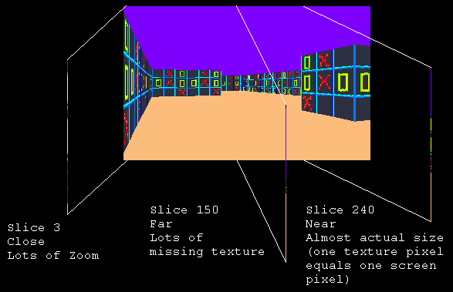

Figure 5: Three strips out of 320 across

Keeping Things Fast

A number of techniques are used to help minimize the execution time of the code. Let us examine them.
The functions that find the horizontal and vertical intersections use a rearranged line equation to solve for the next horizontal or vertical intercept. The equations use the tangent (and inverse tangent) of the ray's angle in their solution. Calculating a trigonometric function during ray casting will slow things down significantly. To eliminate this problem, a array of pre-computed tan and inv-tan values are used as a lookup table during ray tracing. The tables are computed for a specific set of angles at the beginning of the game, before ray casting begins. The set of angles begins at 0 degrees and goes up in fixed increments all the way to 360 degrees. The size (in angles ) of the players field of view and the number of columns in the game screen determine the size of the increments between angles. Rays are only cast out at angles that are represented in the tables.
For every pixel written to the screen, a calculation must be performed to find its address within the video display memory used by the VGA hardware. The 320 by 200 pixel resolution requires a display memory of 64000 bytes. So, pixels have addresses between 0 and 63999. One way to generate the address looks like this:

pixel_address = (row * 320) + column;

This method requires a multiply operation, which really means 64000 multiply operations when drawing an entire screen. This could be very time consuming. Instead, pixel addresses are generated like this:

pixel_address = (row << 8) + (row << 6) + column;

This equation takes advantage of the fact that the sum of 64 and 256 is 320. In addition, shifting a binary number to the left 6 bits (or 8) is equivalent to multiplying the number by 64 (or 256). The shift left operation is much faster than the multiply, and helps keep the address generation time to a minimum.
The third technique involves the use of a #define, rather than a function, to actually plot a pixel on the screen. A pixel-plotting function would require three parameters (row, column, and color) to be pushed onto the runtime stack, along with other necessary information. Once again, this is really 64000 sets of pushes (and pops) for an entire game screen. To speed things up, a #define is used instead. The #define will be expanded into code in place, and not require use of the runtime stack for parameter passing. The #define code is essentially the same code that would be in the function, we have just eliminated the need to call the function.
The #define that plots pixels in the Virtual Maze program is as follows:

#define pp(r,c,color) vbuff[(r<<8)+(r<<6))+c]=color;

vbuff is a pointer initialized to the base address of the video display memory.

The Overall Game Loop

Virtual Maze uses a very simple loop:

1. Get player movements.
2. Ray cast the new scene.

Player movements are controlled by the arrow keys on the keyboard, or by moving the mouse. The up arrow moves the player forward, the down arrow backwards. The left and right arrows rotate the player counterclockwise and clockwise, respectively. Similar movements on the mouse have the same effect.
Once the players new position and direction have been calculated (assuming the player has not tried to walk through a wall), a new scene is rendered. If the player stands still, the ray caster does not render a new scene. This helps to reduce flicker and is acceptable since Virtual Maze is a static environment. A dynamic environment contains things that move, lights that flash, etc. and must be continuously rendered.

